**Supplementary Material**.

**Exploring the Decolorization Efficiency and Biodegradation Mechanisms of Different Functional Textile Azo Dyes by *Streptomyces albidoflavus* 3MGH**

Mohamed E. El Awady1, Fatma N. El-Shall2, Ghada E. Mohamed3, Ahmed M. Abd-Elaziz4, Mohamed O. Abdel-Monem3* and Mervat G. Hassan3

|  |  |  |
| --- | --- | --- |
| **Supplementary table 1.** Chemical structure of selected azo dyes used in study. | | |
| C.I.name | Functionality | Molecular Formula, Molecular Weight, and Chemical Structure |
| Reactive [Orange](http://www.worlddyevariety.com/?s=Orange&submit=Search) 122 | Mono | C31H20ClN7Na4O16S5 1034.27 g·mol−1 |
| Direct Blue 15 | Di | C34H24N6Na4O16S4 992.79 g·mol−1 |
| Direct Black 38 | Tri | C34H25N9Na2O7S2 781.73 g.mol-1 |

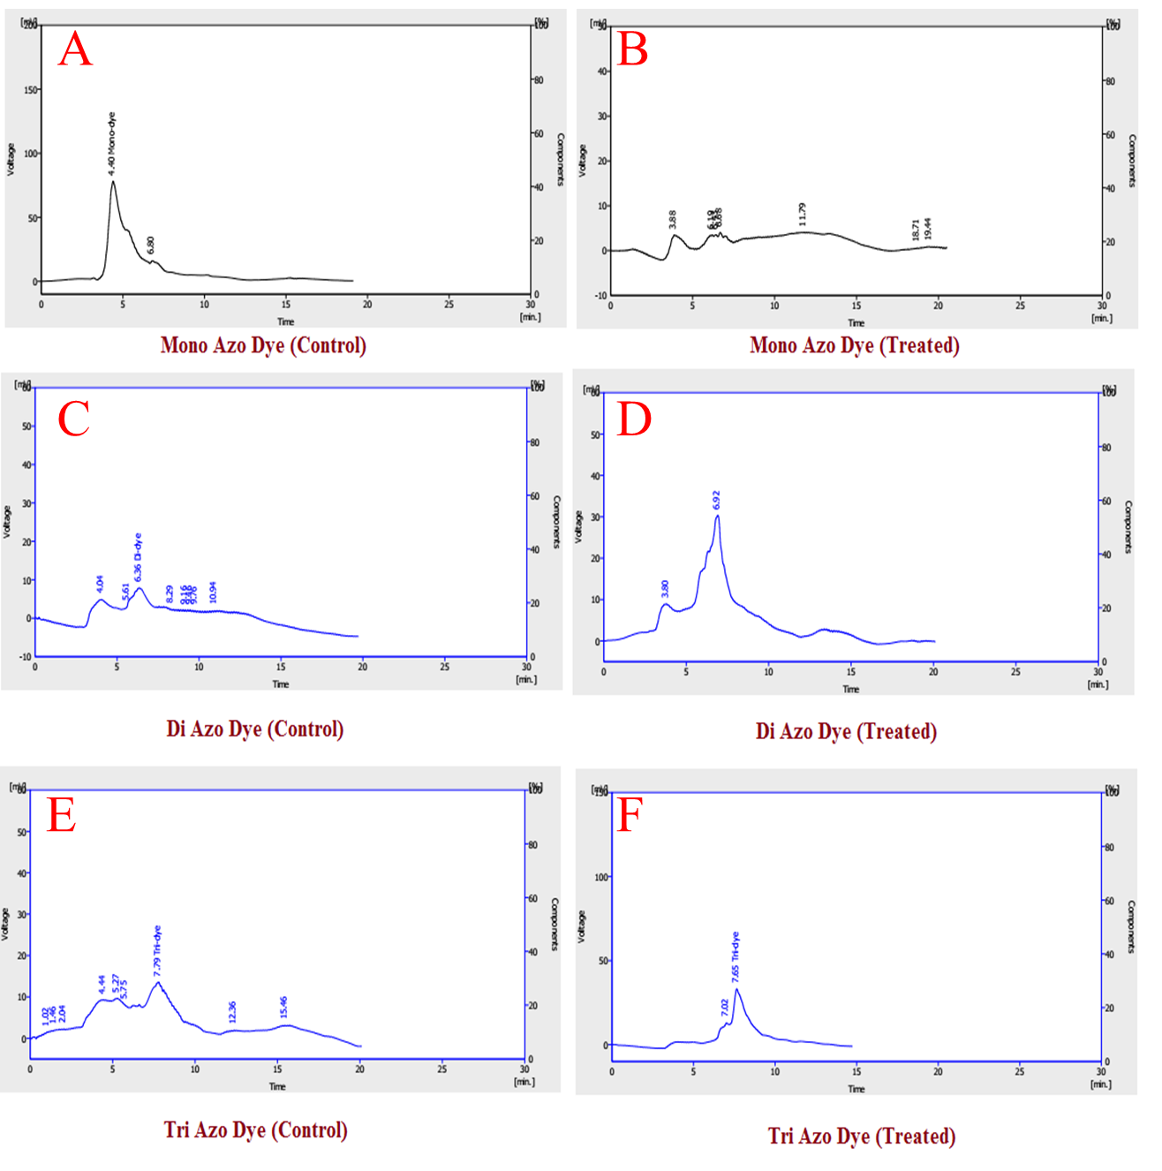

**Supplementary figure 1:** HPLC Chromatogram Profiles of Mono Azo Dye (RO 122) (**A&B**), Di Azo Dye (DB 15) (**C&D**), and Tri Azo Dye (DB 38) (**E&F**) before and after treatment with *S. albidoflavus* 3MGH.